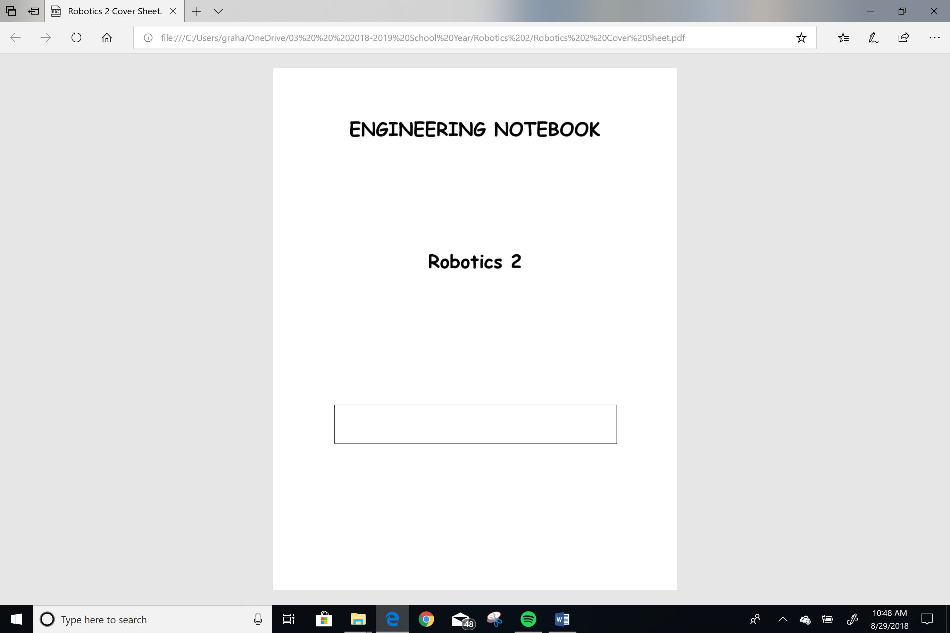

**Cedric McEnroe**

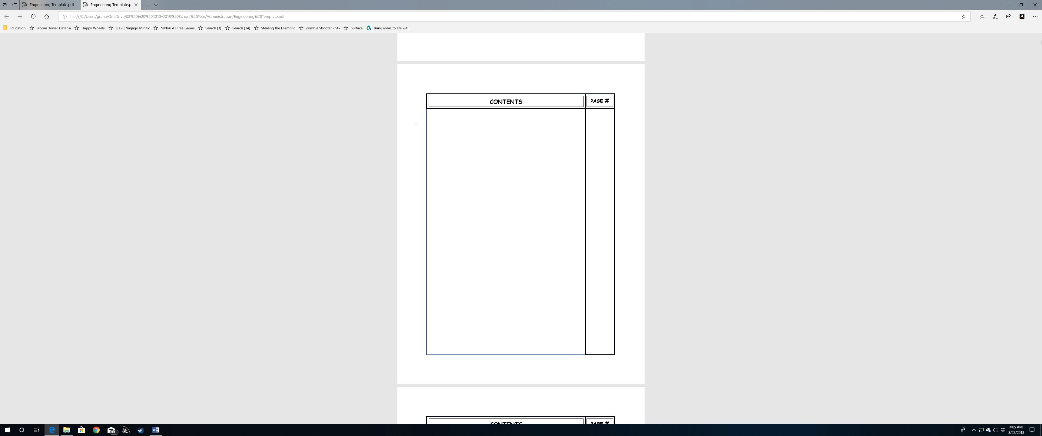

1

Lesson 3.1.L Proportional Control



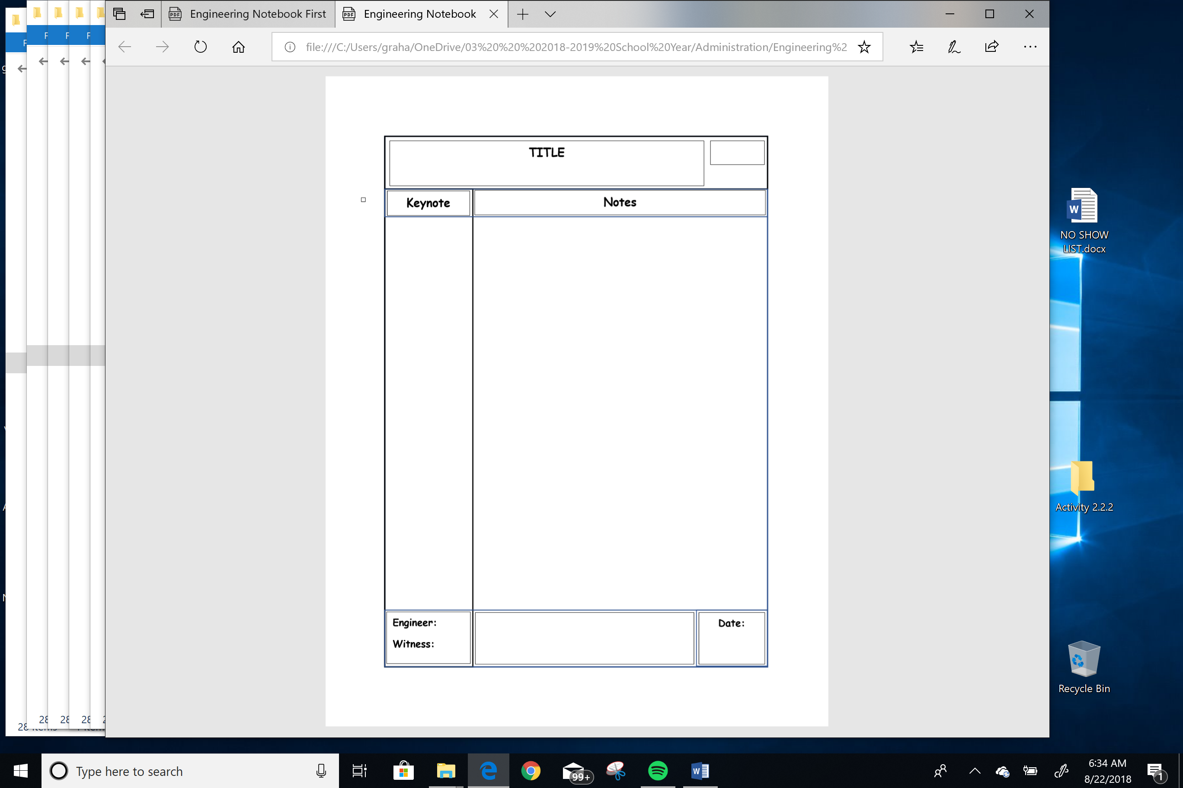

Lesson 3.1.L Proportional Control

**1**

* Learn about proportional control
* Cruise control on a vehicle is a control system

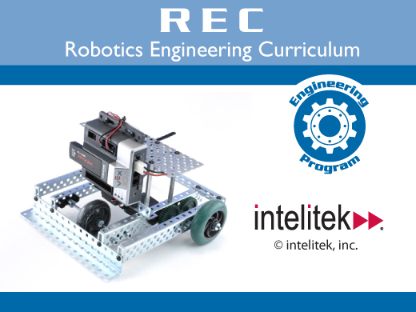

* It uses a network of sensors and throttle controls
* An automated process control system is advantageous where extreme precision and repeatability is requires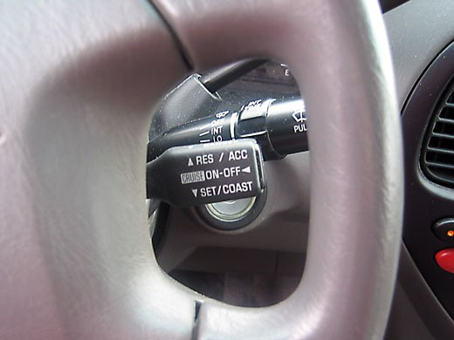
* Process includes controllable variables, such as power given to a motor
* These variables influence the outcome of the process
* An intelligent link, in place of a human is required
* The system responds to the sensor data

Objectives

Process Control Control Systems

Automated Control



**2**

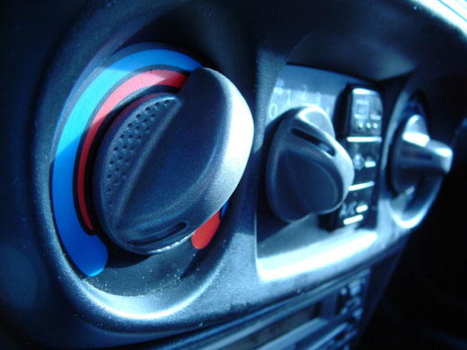

* A good example is the temperature thermostat in a building
* A pump in a factory moving a chemical to several reaction tanks
* The rate at which the chemical enters each tank must be carefully controlled
* When one tank closes the rate at which the chemical is pumped to the other tanks is reduced

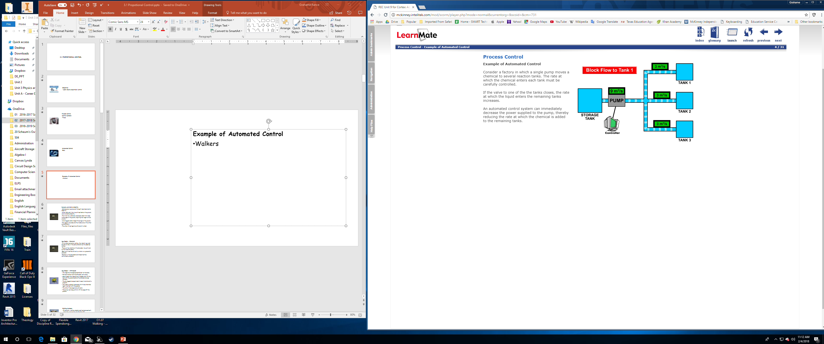

Example of Automated Control



**3**

* A control system to drive a robot at a constant speed.
* Wheel encoders provide feedback on the cars current speed.
* On a flat road the speed is constant.
* The program needs to supply more power to the motors when the robot is climbing.
* Less power when it is rolling downhill.

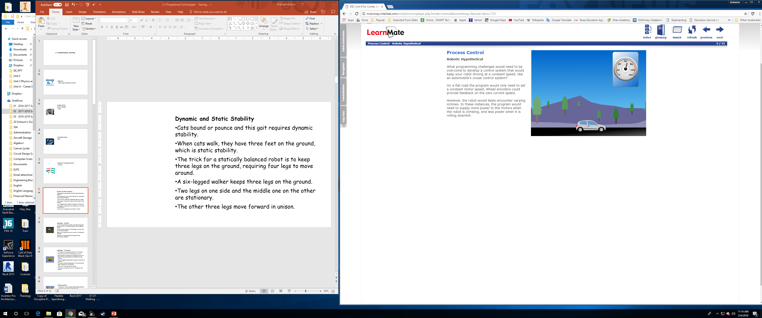

* An on-off system can be controlled with a switch
* Think if a water tower in a sub-division
* When the water level drops to a certain level the pump should be automatically turned on to top up the water.
* 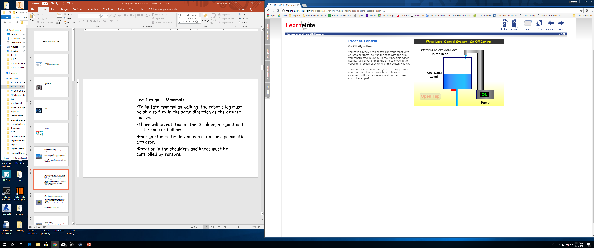

Robotic Hypothetical

On-Off Algorithm



**4**

* The main disadvantage with an on-off switch is the power is constant when the switch is on
* On could be too fast or too slow, depending on the setting.
* A program could be written to incrementally add more power when the robot is moving too slowly
* Less power if moving too fast
* A step-like response, as shown would be created
* If a robot is going uphill then the controller increases the PWM output in small steps until the motors compensate and reach the set speed.
* On steeper inclines the program in the previous example would not work
* The motor response would be too slow
* This is due to the time the program spends waiting to check for the new speed of the robot
* If the program did not wait, the PWM values would reach maximum before ant physical response and over-adjust
* The target speed would be exceeded
* The program needs to apply more or less power to the motors as necessary
* This is what happens when you drive the robot with tank or arcade drive
* The more you push on the joysticks, the faster the robot drives

Disadvantages of On-Off

Step Control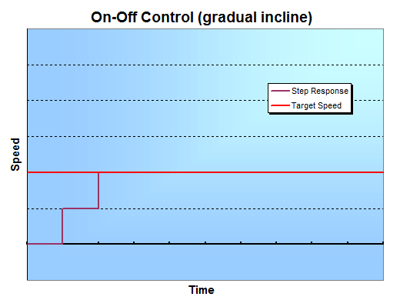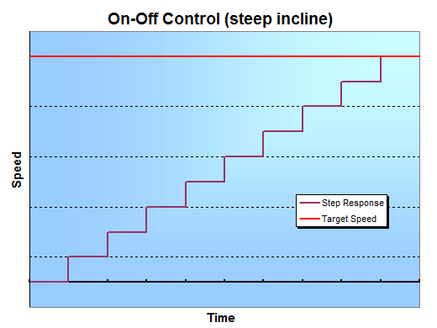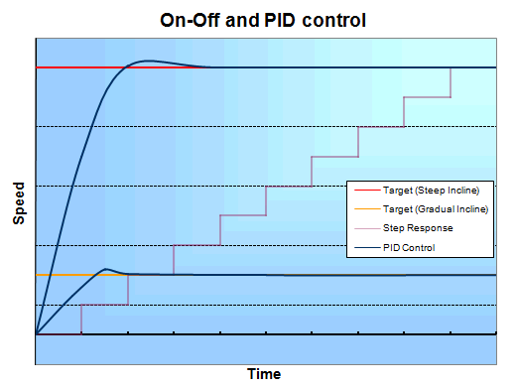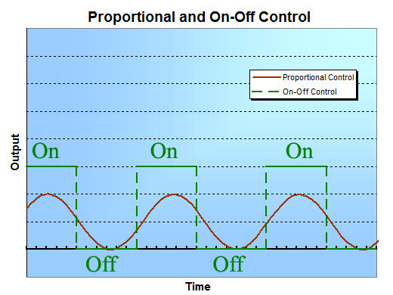



**5**

* This method of control is “proportional control.”
* Proportional control constantly adjusts speed, in place of on-off switches
* The algorithm reads the robot’s current speed and compares it to the target speed
* The smoother response reduces wear and tear on the robot
* It smooth’s away the highs and lows

Proportional Control vs On-Off system



**6**



**7**



**8**



**9**



**10**



**11**



**12**



**13**



**14**



**15**



**16**



**17**



**18**



**19**



**20**



**21**



**22**



**23**



**24**



**25**



**26**



**27**



**28**



**29**



**30**



**31**



**32**



**33**



**34**



**35**



**36**



**37**



**38**



**39**



**40**



**41**



**42**



**43**



**44**



**45**



**46**



**47**



**48**



**49**



**50**



**51**



**52**



**53**



**54**



**55**



**56**



**57**



**58**



**59**



**60**



**61**



**62**



**63**



**64**



**65**



**66**



**67**



**68**



**69**



**70**



**71**



**72**



**73**



**74**



**75**



**76**



**77**



**78**



**79**



**80**



**81**



**82**



**83**



**84**



**85**



**86**



**87**



**88**



**89**



**90**



**91**



**92**



**93**



**94**



**95**



**96**



**97**



**98**



**99**



**100**



**101**



**102**



**103**



**104**



**105**



**106**



**107**



**108**



**109**



**110**



**111**



**112**



**113**



**114**



**115**



**116**



**117**



**118**



**119**



**120**



**121**



**122**



**123**



**124**



**125**



**126**



**127**



**128**



**129**



**130**



**131**



**132**



**133**



**134**



**135**



**136**



**137**



**138**



**139**



**140**



**141**



**142**



**143**



**144**



**145**



**146**



**147**



**148**



**149**



**150**



**151**



**152**



**153**



**154**



**155**



**156**



**157**



**158**



**159**



**160**



**161**



**162**



**163**



**164**



**165**



**166**



**167**



**168**



**169**



**170**



**171**



**172**



**173**



**174**



**175**



**176**



**177**



**178**



**179**



**180**



**181**



**182**



**183**



**184**



**185**



**186**



**187**



**188**



**189**



**190**



**191**



**192**



**193**



**194**



**195**



**196**



**197**



**198**



**199**



**200**